**Implement programs for visualizing time series data**

**EX:No.2**

**DATE:15/02/25**

**AIM:**

To analyze and visualize stock trends using time series plots, moving averages, volume analysis, and daily returns.

**ALGORITHM:**

1. Load Data – Import libraries and read the AAPL stock dataset.
2. Preprocess – Convert 'Date' to datetime, sort, and set it as the index.
3. Handle Missing Values – Check and fill missing values using forward-fill.
4. Plot Closing Price – Visualize AAPL's 'Close' price over time.
5. Moving Averages – Compute and plot 7-day & 50-day moving averages.
6. Volume Analysis – Plot cumulative and daily traded volume trends.
7. Daily Returns – Calculate and visualize percentage price changes.

**CODE:**

import pandas as pd

import matplotlib.pyplot as plt

import seaborn as sns

file_path = 'AAPL.csv' # Replace with the path to your dataset

data = pd.read_csv('/content/AAPL.csv')

print("First few rows of the dataset:")

print(data.head())

if 'Date' in data.columns:

data['Date'] = pd.to_datetime(data['Date'])

data = data.sort_values(by='Date')

else:

raise ValueError("The dataset must have a 'Date' column.")

data.set_index('Date', inplace=True)

print("\nChecking for missing values:")

print(data.isnull().sum())

data.fillna(method='ffill', inplace=True)

plt.figure(figsize=(12, 6))

sns.set_style('whitegrid')

if 'Close' in data.columns:

plt.plot(data.index, data['Close'], label='Close Price', color='blue')

plt.title('AAPL Stock Price Over Time')

plt.xlabel('Date')

plt.ylabel('Stock Price')

plt.legend()

plt.show()

else:

raise ValueError("The dataset must have a 'Close' column for stock prices.")

data['MA_50'] = data['Close'].rolling(window=50).mean() # 50-day Moving Average

plt.figure(figsize=(12, 6))

plt.plot(data.index, data['Close'], label='Close Price', color='blue', alpha=0.5)

plt.plot(data.index, data['MA_50'], label='50-Day MA', color='orange', linewidth=2)

plt.title('AAPL Stock Price with 50-Day Moving Average')

plt.xlabel('Date')

plt.ylabel('Stock Price')

plt.legend()

plt.show()

data['Cumulative_Volume'] = data['Volume'].cumsum()

plt.figure(figsize=(12, 6))

plt.plot(data.index, data['Cumulative_Volume'], label='Cumulative Volume', color='darkgreen')

plt.title('AAPL Cumulative Volume Traded Over Time')

plt.xlabel('Date')

plt.ylabel('Cumulative Volume')

plt.legend()

plt.show()

plt.figure(figsize=(12, 6))

plt.plot(data.index, data['Close'], label='Close Price', color='blue', alpha=0.5)

plt.plot(data.index, data['MA_7'], label='7-Day MA', color='red', linewidth=2)

plt.plot(data.index, data['MA_50'], label='50-Day MA', color='orange', linewidth=2)

plt.title('AAPL Stock Price with 7-Day and 50-Day Moving Averages')

plt.xlabel('Date')

plt.ylabel('Stock Price')

plt.legend()

plt.show()

data['Daily_Return'] = data['Close'].pct_change() * 100

plt.figure(figsize=(12, 6))

plt.plot(data.index, data['Daily_Return'], label='Daily Percentage Change', color='purple')

plt.title('AAPL Daily Percentage Change (Returns) Over Time')

plt.xlabel('Date')

plt.ylabel('Percentage Change (%)')

plt.legend()

plt.show()

plt.figure(figsize=(12, 6))

plt.bar(data.index, data['Volume'], color='lightcoral')

plt.title('AAPL Volume Traded Over Time')

plt.xlabel('Date')

plt.ylabel('Volume')

plt.xticks(rotation=45)

plt.show()

**OUTPUT:**

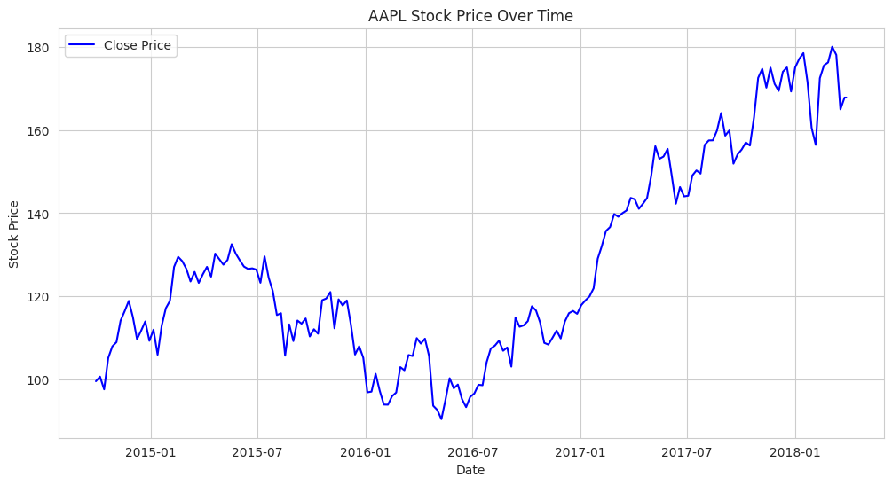

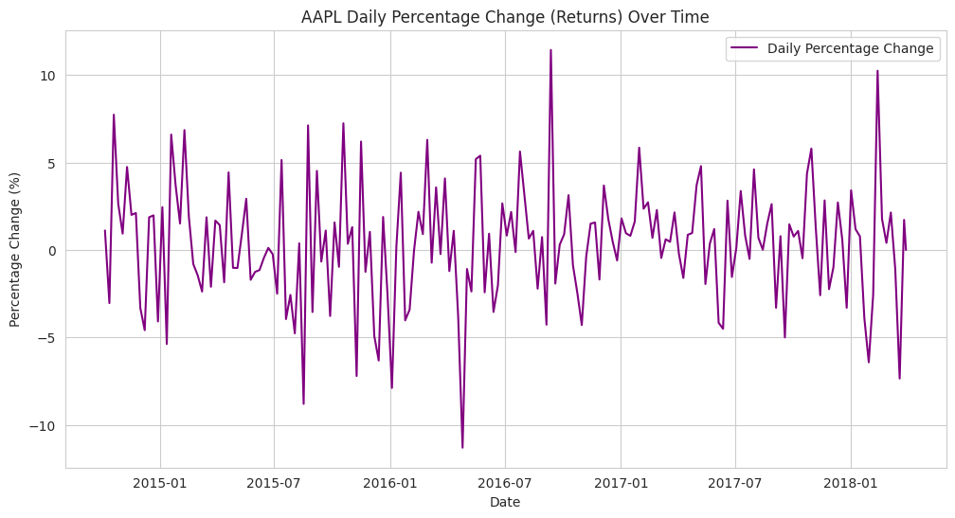

**RESULT:**

Thus the program has been completed and verified successfully.